Fabric Consumption Prediction using Linear Regression
Professional Project Documentation
• Project Overview
• Technologies Used
• Dataset
• Model Building Steps
• Python Implementation
• Model Evaluation
• Model Serialization (Pickle)
• Streamlit Application
• Workflow
• Conclusion
• Sample Training Code

Project Overview
This project predicts fabric required based on the number of garments using Simple Linear Regression. The trained model is saved using Pickle and deployed with Streamlit.

Technologies Used
Python
Pandas
NumPy
Scikit-Learn
Pickle
Streamlit
import numpy as np
import pandas as pd
import pickle
import os

from sklearn.model_selection import train_test_split
from sklearn.linear_model import LinearRegression
from sklearn.metrics import (
mean_absolute_error,
mean_squared_error,
r2_score
)
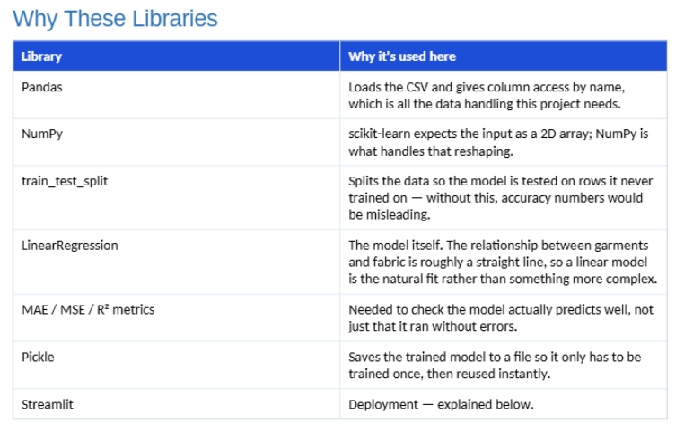

Dataset
Input: Number_of_Garments
Independent Variable : X
Output: Fabric_Required_kg
Dependent Variable : Y
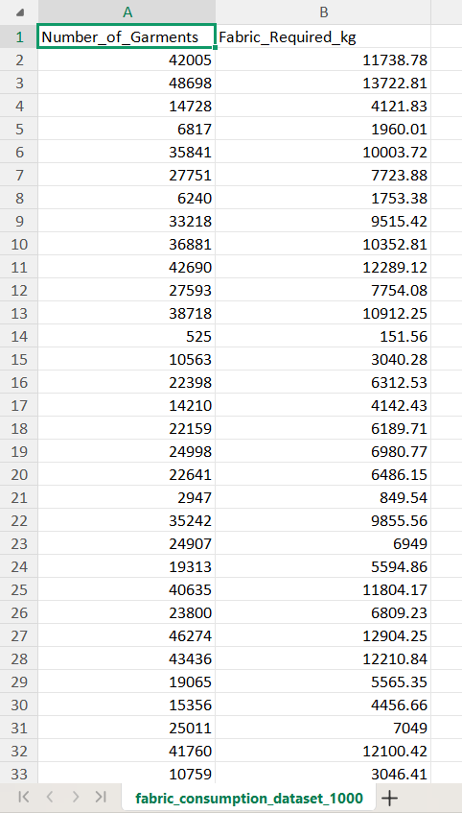

Model Building Steps
Import libraries.
Load dataset.
Select X and y.
Split dataset.
Train Linear Regression model.
Predict test data.
Evaluate with MAE, MSE, RMSE and R².
Save the model using Pickle.
# ==========================================
# Fabric Consumption Prediction Model
# ==========================================

# Import Libraries
import numpy as np
import pandas as pd
import pickle
import os

from sklearn.model_selection import train_test_split
from sklearn.linear_model import LinearRegression
from sklearn.metrics import (
mean_absolute_error,
mean_squared_error,
r2_score
)

# ==========================================
# Load Dataset
# ==========================================

dataset = pd.read_csv(r"C:\Users\laksh\Downloads\FSDS\fabric_consumption_dataset_1000.csv")

# ==========================================
# Define Independent Variable (X)
# ==========================================

X = dataset[['Number_of_Garments']].values

# ==========================================
# Define Dependent Variable (y)
# ==========================================

y = dataset['Fabric_Required_kg'].values

# ==========================================
# Split Dataset
# ==========================================

X_train, X_test, y_train, y_test = train_test_split(
X,
y,
test_size=0.20,
random_state=0
)

# ==========================================
# Train Linear Regression Model
# ==========================================

model = LinearRegression()

model.fit(X_train, y_train)

# ==========================================
# Predict Test Data
# ==========================================

y_pred = model.predict(X_test)

# ==========================================
# Model Parameters
# ==========================================

print("\nCoefficient (Slope)")
print(model.coef_)

print("\nIntercept")
print(model.intercept_)

mae = mean_absolute_error(y_test, y_pred)
mse = mean_squared_error(y_test, y_pred)
rmse = np.sqrt(mse)

print("\n" + "=" * 50)
print("ERROR METRICS")
print("=" * 50)

print("\nMean Absolute Error (MAE)")
print(round(mae, 4))

print("\nMean Squared Error (MSE)")
print(round(mse, 4))

print("\nRoot Mean Squared Error (RMSE)")
print(round(rmse, 4))

print("\nR² Score")
print(round(r2_score(y_test, y_pred), 2))

# ==========================================
# Save Model using Pickle
# ==========================================

with open("fabric_model.pkl", "wb") as file:
pickle.dump(model, file)

# ==========================================
# Verify Model Saved
# ==========================================

print("\n" + "=" * 50)

if os.path.exists("fabric_model.pkl"):
print("Model Saved Successfully!")
print("File Name : fabric_model.pkl")
else:
print("Model Saving Failed!")

print("=" * 50)

Streamlit Steps
Load pickle model.
Create title.
Accept garment input.
Predict fabric.
Display result.
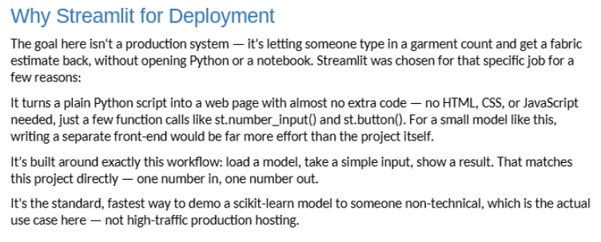
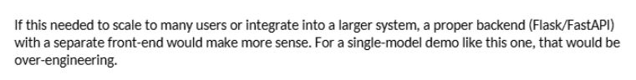

# ==========================================
# Fabric Consumption Prediction Web App
# Developed using Streamlit
# ==========================================

# Import Libraries
import streamlit as st
import pickle
import numpy as np

# ==========================================
# Page Configuration
# ==========================================

st.set_page_config(
page_title="Fabric Consumption Predictor",
page_icon="🧵",
layout="centered"
)

# ==========================================
# Load Trained Model
# ==========================================

with open("fabric_model.pkl", "rb") as file:
model = pickle.load(file)

# ==========================================
# Application Title
# ==========================================

st.title("🧵 Fabric Consumption Predictor")

st.markdown("""
### Predict the amount of fabric required based on the number of garments.

This Machine Learning application is built using:

- Python
- Scikit-Learn
- Simple Linear Regression
- Pickle
- Streamlit
""")

st.divider()

# ==========================================
# User Input
# ==========================================

garments = st.number_input(
"Enter Number of Garments",
min_value=1,
value=100,
step=1
)

# ==========================================
# Prediction
# ==========================================

if st.button("Predict Fabric Requirement"):

# Convert input into 2D array
input_data = np.array([[garments]])

# Predict
prediction = model.predict(input_data)

fabric_required = round(float(prediction[0]), 2)

st.success(
f"Estimated Fabric Required: **{fabric_required} kg**"
)

st.info(
f"For **{garments} garments**, approximately **{fabric_required} kg** of fabric will be required."
)

st.divider()

# ==========================================
# Footer
# ==========================================

st.caption("Developed using Scikit-Learn + Streamlit")

Workflow
Dataset → Training → Evaluation → Pickle Model → Streamlit → User Input → Prediction

Conclusion
The application accurately predicts fabric consumption and provides an easy-to-use web interface.

Sample Training Code
dataset = pd.read_csv(...)
X = dataset[['Number_of_Garments']].values
y = dataset['Fabric_Required_kg'].values
X_train, X_test, y_train, y_test = train_test_split(X,y)
model = LinearRegression()
model.fit(X_train,y_train)
pickle.dump(model, open('fabric_model.pkl','wb'))
